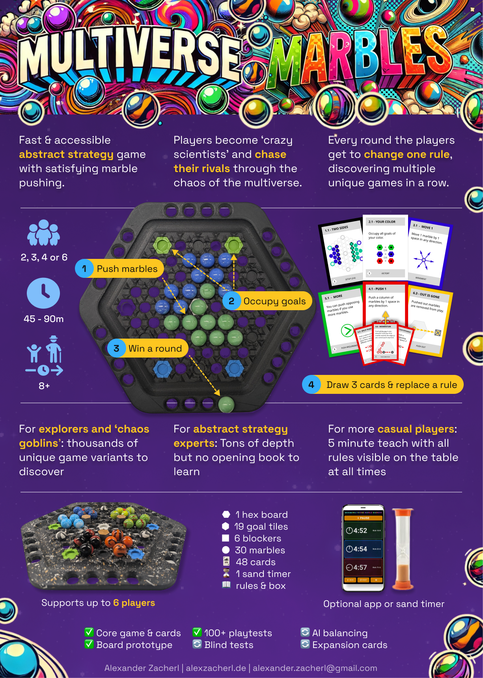

**Multiverse Marbles**

*Push marbles, occupy goals, and* ***chase your rivals*** *through the multiverse. Every round you enter a new dimension,* ***change a rule,*** *and can be sure to never play the same game twice. But be warned: The* ***chaos level is constantly rising*** *in this duel between scientific geniuses.*

**Players: 2, 3, 4 or 6 Playtime: 90 minutes Age: 8+**

## **Components How To Win**

* 1 board Be the first player or
* 9 hexagonal goals (2 red, 2 green, 2 blue, 3 gray) -> team to **stash 4 marbles**
* 10 blue marbles (5 dark & 5 light) on the *border slots* (by
* 10 green marbles (5 dark & 5 light) winning 4 rounds).
* 10 red marbles (5 dark & 5 light)
* 3 blockers
* 3 black holes
* 50-ish rule cards
* 2 reference cards
* 6 blank cards

  
All components set up for a 2-player game

**Setup**

**Note:** Yellow text shows rule modifications for 3, 4 or 6 player games. When playing with 2 players: Ignore any yellow text.

## Cards & The Rules Display

To get started we first need to set up the rule cards:



1. Flip the **stack of cards** face-up.

***Do not shuffle*** *the draw stack or re-order it, unless told to do so.*

1. Remove the **cover card** (“start here”) and put it on the side, face-up, to start your **discard pile**.
2. Draw the **next 6 face-up** **rule cards** from the stack. You’ll have 1 card of each color.
3. Place these 6 cards in a 3-by-2 **rules display**, so that they are visible to all players. (Right column: 1.1, 2.1 and 3.1; Left column: 4.1, 5.1 and 6.1).
4. Flip the black SETUP card to the correct side for your player number: For **2 or 4** players use the front(**1.1 Two Sides**). For **3 or 6** players use the back (**1.19 Circles**).
5. Put the 2 white **reference cards** (FAQ/ SNEAKY RULES, THE TIMER) face-up next to you, so you can peek at them while you play.
6. Keep all remaining rule cards in a face-down **draw** **pile** next to the rules display.

## The Board & Marbles

Next it is time to put some marbles on the board!

1. Put the **game board** in between the players, so everyone can reach it easily.
2. Place the **hexagonal goals** into the 7 free slots on the board (the bigger holes) according to the black 1.x SETUP rule card you selected before.   
   For **2 or 4** players place 2 green and 2 blue goals on opposing sides, and 3 grey goals in the center slots as  **1.1 Two Sides** shows. For **3 or 6** players place 2 each of the red, green and blue goal on the outside and one grey goal in the center as **1.19 Circles** shows.
3. Now **place the marbles** the onto the hex grid as displayed on the *same 1.x SETUP cards*.  
   **For 4 and 6 players**: Pay attention to the *shading* of the marbles on the setup. Place the marbles with the darker pattern where the shaded marbles are on the setup card, and the lighter pattern on the non-shaded spots. (You can ignore shading for 2 and 3 player games.)
4. Put the **box** on the other side and keep any additional goals, marbles, **blockers** and **black holes** in there.

## The Timer

Multiverse Marbles is best played fast, without overthinking, to let you explore many different rules. So it is important to set up a timer.



1. We suggest to use the **mobile web app** (use the QR code on the right on on the timer reference card). It works on all mobile phones, does not require a download and even comes with sound effects! When a player runs out of time, they (and their team) lose this round.
2. Don’t have a phone or internet access? Use the 30s **sand timer** in the box**.** You do not have to constantly flip it. Instead, any player can flip it in front of another player, when that player takes too long. If they don’t make a move before the sand runs out, they lose their turn.

## *Terminology*

* ***Action****: One player makes a move or push.*
* ***Turn****: Every player has taken one action.*
* ***Round****: All players/teams have won/lost according to the current 2.x VICTORY card.*
* ***Game****: One player/team has won 4 rounds.*
* ***Line****: A line of 5-9 fields on the board.*
* ***Column****: A connected group of marbles of one player/team’s color in one line.*

## 

## **Quick Start**

To win a game of *Multiverse Marbles*, you need to **win 4 out 7 rounds**. Each round you will **take turns** and play the game as defined by the 6-card **rules display** next to the board.

There are always **6 cards in a rules display**, with one card of each of the 6 types:

* **SETUP (black)**: Defines where goals, marbles, blockers and black holes start off.
* **VICTORY (white)**: How to win (or lose) a game.
* **MOVEMENT (blue)**: How to move one (or multiple) of your marbles into a free space.
* **PUSH DIRECTION (red)**: In which direction (and how far) marbles can be pushed.
* **PUSHING OPPONENTS (green)**: What marbles you need to push your opponent.
* **PUSH OUT (yellow)**: What happens, when a marble gets pushed out of the grid.

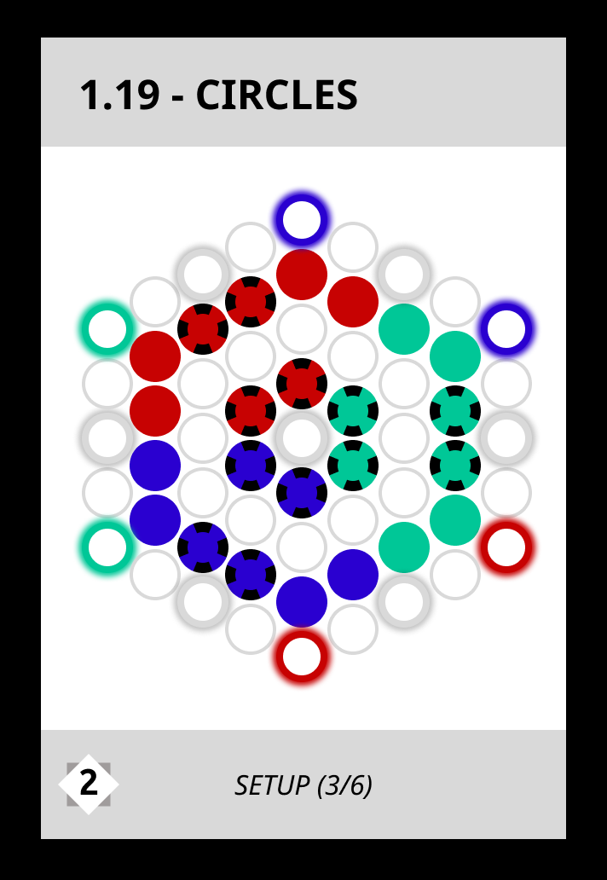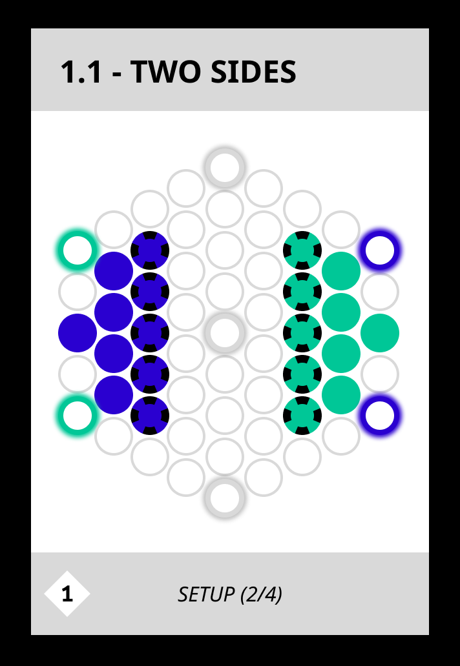

Turn Order  
You already set up the board using the **1.1 - TWO SIDES** SETUP rule card (or **1.19 CIRCLES)**. This card shows you how to set up the goals and marbles but also where to sit: Every player sits next to the marbles of their color (and generally away from the goals in their color).

Now **decide on a starting player** (by default, green goes first). **Play is always in clockwise order**. The illustration below shows the turn order for 2, 3 4 and 6-player games with green as the starting player.

**For 4 and 6 players**: Form teams of two players each and decide, for each team, which player will play with the **dark** and which will play with the **light** marbles. Ensure that the seating order around the board is correct: Blue-Dark → Green-Dark → Blue-Light → Green-Light etc. (see the illustration on the page before). This means that the we always alternate between the dark and light players of the teams and no team goes twice in a row.

## 

## How to Win a Round

To win a round (and ultimately 4 rounds to win the game), do what the **2.1 - YOUR COLOR** VICTORY rule card on the table says: Have two marbles of your color on two goals of your color - even just brifly. At this point the game instantly ends (other players does not get another turn).

*The goals are like any other space. Any player can occupy them with their marbles (so you can block the goal of the opponent’s colors). Your marbles can be pushed off the goals, so don’t expect them to be ‘safe’. (More about pushing later.)***For 4 and 6 player games**: Be aware that all members of a team win and lose together. =D

## Actions: Movement and Pushing

Every turn you can take one action: either a **Move** or a **Push.** 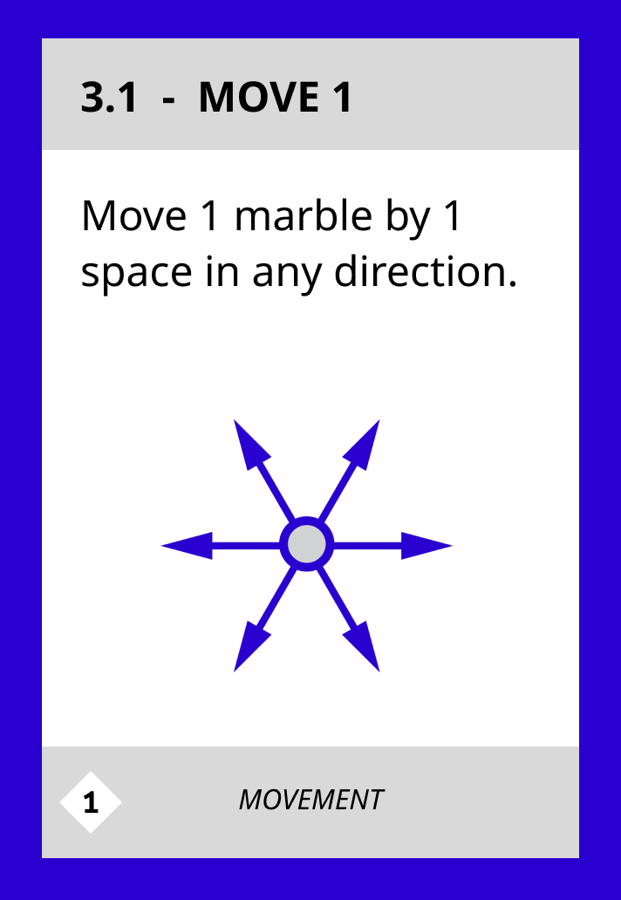

Rule card **3.1 - MOVE 1** explains how you move: You nudge one of your marbles into a neighboring, empty space. You can move into any of the 6 directions by one space.

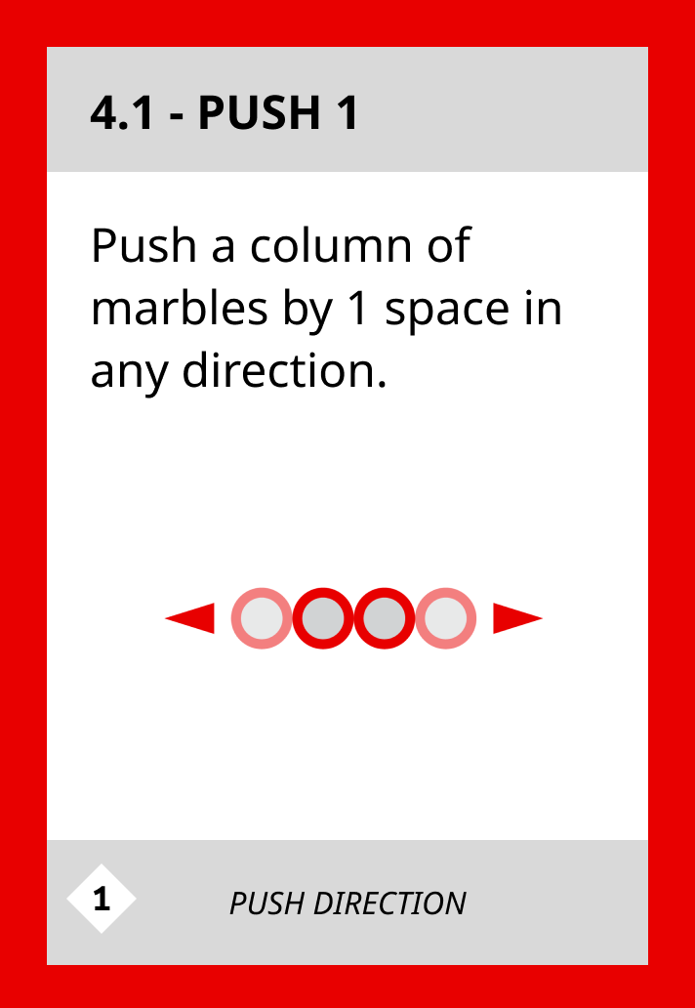

Rule card **4.1 - PUSH 1** shows you how to push. You can **push one of your marbles** in any of the 6 directions on the hex grid, always by one space. It will then push the other marbles in front of it. You can always push *any number* of your *own* marbles.

*Remember, you either move or you push. Those two actions cannot be combined in one turn (unless a card explicitly says so). Moving is always into empty space. Pushing always involves multiple marbles.*

**For 4 and 6 player games**: Each player can *only* start a Move or Push with their own marbles. For example: The Blue-Dark player can only move or push with a Blue-Dark marble. But they treat the Blue-Light marbles as their own when it comes to being pushed (“you can always push your own marbles”). When a player cannot legally move one of their own marbles they are now free to move any marbles of their team mate as well.

You probably now want to also push your opponent's marbles. This is possible! As rule card **5.1 PUSHING OPPONENTS** shows, you need to push more of your own marbles than the number of opposing marbles you want to push. For example, 2 of your marbles can push 1 of the opponent's marbles. If you have a third marble, you can push 1 or 2 marbles, and so on.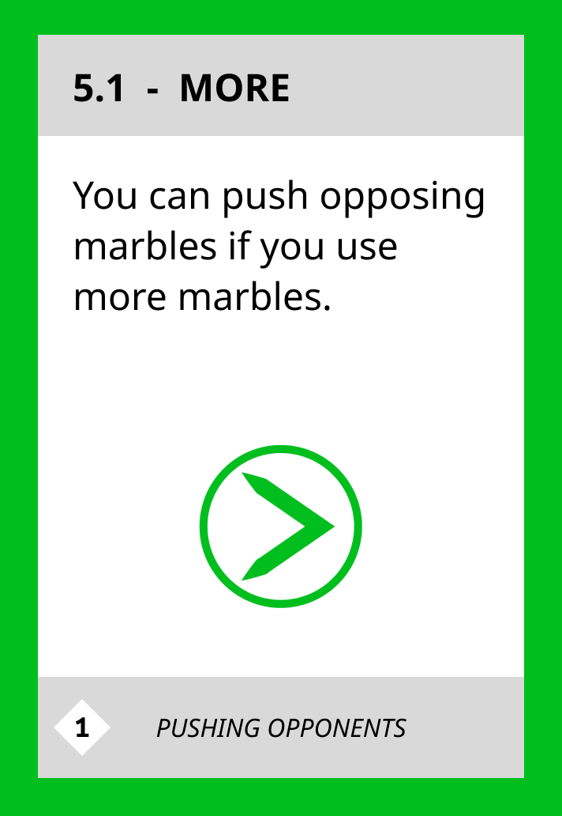

**For 3 or more players**: Any card that talks about an ‘opposing marble’ now applies to *both* colors that are not your own. So the blue player, for example, can push both a red and a green marble with their own 3 green marbles (since the total number of opposing marbles is 2). 

*The ‘chain rule’ applies when there are more than 2 columns of marbles in a push. Each column must be able to push the next one, otherwise a push is blocked.*   


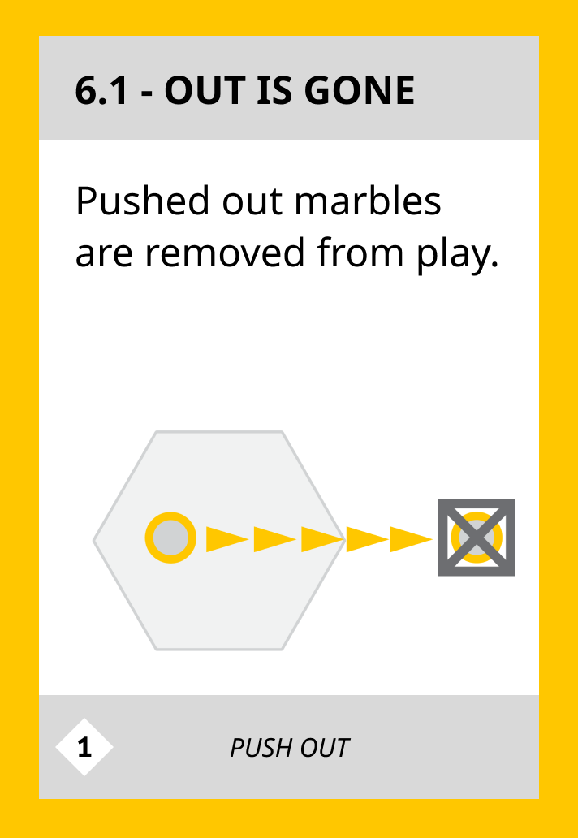

It is also possible to push marble off the grid. For this case rule card **6.1 - OUT IS GONE** defines what happens: The pushed out marble stays out of the grid and cannot be used anymore. (But no worries, it will come back in the next round).

*You can push yourself out of the grid (unless a rule card specifically prevents this). But you can’t just move a marble out on its own.*

**One important note for 3 or 6 player games**: When the first player (or team) wins or loses, all of their marbles get removed from the grid. The other two players (or teams) continue playing until the end!

*Note: You can always concede a game or offer your opponent a draw. There’s no shame in quickly going from a lost round to a new opportunity.*

This is all the information you need to play your first round. Go play and come back here after your first round and continue reading on the next page, under ‘Round Structure’.

*If you get stuck or confused during play, look at the ‘Sneaky Rules’ reference card on the table and if that does ont help, head down to the Frequently Asked Questions (FAQ) section.*

## 

## **Round Structure**

Congrats on winning (or losing) your first round! Now comes the fun part.

## Change the rules!

First the **losing** **player** (or team) **draws the top three cards** from the draw pile, **shows them** to their opponent(s), and **selects up to* one**. The selected card goes on top of the card of the same color in the rule card display. All players must obey this new rule in the next and in all future games. The other two cards now get discarded.

*\* The losing player can decide not to change the rules. We suggest you do that rarely. The gods of multiverse travel don’t look favorably on cowards.*

*Note that the SETUP cards are two-sided. When you draw the wrong kind of card for your current number of players, just flip it.*

Unsure which card to choose? Let yourself be guided by the **Chaos Level** on the bottom left of the card. A higher number generally means that a game will be more chaotic and challenging. Perfect for *Chaos Goblins*. If you want a more relaxed game, go for a lower number.

Now that this is done, it is time to **go over the current rule display together**. Remind yourself (and your opponent), by what rules you are currently playing.

## Set up the board

**Now the winner** (3/6 player games: the 1st winner) **sets up the game board** for the next round. They put all marbles back into their original positions as defined by the current 1.x SETUP rule card.

Then the winner(s) **stash one of their marbles** on a slot next to them outside the hex grid. This marks their first won round - they will play without this marble in future rounds. This makes the game harder for them but also more rewarding to win. (3/6 player games: Both the first and the second winner get to stash a marble.)

To find out which of the starting positions stays empty, just ‘scan’ through the lines of the hex grid from your position. Marbles get removed from the bottom left.

**For 3 and 6 player games**: Each team first stashes a light marble, then a dark one, then another light one etc. Keep the numbers of marbles per player on the team roughly the same.

**Then the losing player starts the next game.**

**For 4 and 6 player games**: If the last round was started by the *dark* player of one team, it now gets started by the *light* player of the losing team (and vice versa).

This is all you need to play a full game of Multiverse Marbles. Start playing a new round with modified rules. Continue changing the rules and playing more rounds until one player / team has won 4 rounds and stashed 4 marbles. Have fun!

**For 3 or 6 player games**: If two players get to 4 marbles in the same round, then the first one to get there is the overall winner!

*When you reach the end of the draw deck, shuffle the discard pile and form a new draw deck.*

# **Frequently Asked Questions (FAQ)**

You don’t have to read these to get started but if you run into any unclear situations, look here to find the answers. These will be repeated on the *Sneaky Rules* reference card on your table.

1. **What happens when I run out of marbles?** You lose when you have fewer marbles than you need to win.
2. **Can I both move *and* push in one turn?** No, you either move your marbles (like the 3.x rule cards say) ***or*** you push marbles (yours and/or the opponents’, as the 4.x, 5.x and 6.x rule cards describe).
3. **Can I skip a turn? Or “move zero spaces”?** No. You have to make a move even if that makes your position worse.
4. **Can I move around corners?** No, unless otherwise specified all moves and pushes are in a straight line and cannot take 60-degree turns on the board.
5. **Can I take my own marbles off the grid**? Yes, you can push your own marbles off with another marble. But you *cannot* just move a marble off on its own.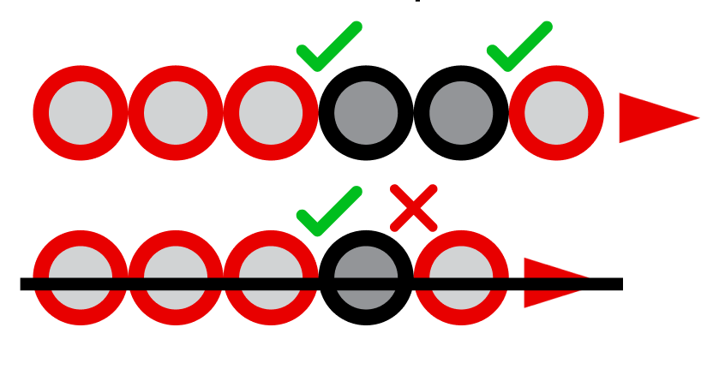
6. **Can I push my own marbles by pushing the opponent’s marbles?** Yes, but the ‘chain rule’ says that each column must be able to push the next.
7. **Can I undo the opponent’s move by pushing back the exact same marbles?** No, you cannot undo your opponent’s move right away. Your turn can’t re-create the board state as it was right before your opponent’s last turn. (You are free to “push back” in a later turn or to push more or fewer marbles than the opponent used.)
8. **What happens if we always repeat a certain pattern?** If the same game state appears for the third time in a game, the game ends in a draw. But be aware of the “cannot un-do your opponent’s move right away” rule above. This should be very uncommon.
9. **What if we run out of cards to draw?** Shuffle the discard pile and create a new draw stack, now with extra randomness!
10. **What happens if multiple players reach their goal in the same turn?** In this case the active player (who just made a move) wins.
11. **What happens if you only fulfill the victory condition for a part of a move (like during a double-push)? Or part of an opponents move?** You still win. =D There is no need to “end your move” on the goals or anything like that.

# **Playing Again / Resetting The Game**

* When all players have played the game before, do not start with the original six rule cards. Instead draw 1 random SETUP card and 1 random other rule card and start from this rule set. This means you won’t always start with the exact same base game.

*[There should be information here about how to reset the game back to the original state, sort the card stack as it was. But alas there isn’t yet. Stay tuned!]*

# 

# **All Rule Cards and Per-Card FAQ**

Do you have any questions about rule cards? Want to know how they interact with each other? Or just what cards exist? Read on!

| ID | Type | Title | Text | Clarifications |
| --- | --- | --- | --- | --- |
| 1.1 | SETUP | Two Sides | - | - |
| 1.2 | SETUP | Clusters | - | - |
| 1.3 | SETUP | Outliers | - | Blockers prevent any movement or pushing through this tile. They cannot be moved. |
| 1.4 | SETUP | Black Hole | - | Being pushed into a "black hole" is like being pushed out. The 6.x PUSH OUT rules apply to it. |
| 1.5 | SETUP | Twin Peaks | - | Blockers prevent any movement or pushing through this tile. They cannot be moved. |
| 1.6 | SETUP | Scylla & Charybdis | - | Being pushed into a "black hole" is like being pushed out. The 6.x PUSH OUT rules apply to it.  Being pushed into a "black hole" is like being pushed out. The 6.x PUSH OUT rules apply to it. |
| 1.7 | SETUP | Circles | - | - |
| 1.8 | SETUP | Clover | - | - |
| 1.9 | SETUP | Line Dance | - | Blockers prevent any movement or pushing through this tile. They cannot be moved. |
| 1.10 | SETUP | Gravity | - | Being pushed into a "black hole" is like being pushed out. The 6.x PUSH OUT rules apply to it. |
| 1.11 | SETUP | Distant Friends | - | Blockers prevent any movement or pushing through this tile. They cannot be moved. |
| 1.12 | SETUP | Solar Punks | - | Being pushed into a "black hole" is like being pushed out. The 6.x PUSH OUT rules apply to it. |
| 2.1 | VICTORY | Your color | Occupy all goals of your color. | - |
| 2.2 | VICTORY | One of each | Occupy 1 goal of each color. | This does not include the neutral (grey) goals. Needs to be green, blue or red. |
| 2.3 | VICTORY | Diagonal | Occupy 2 opposing goals and the center (if it exists). | If the center has a blocker or black hole then you just need two opposing goals. Opposing means they are on a "virtual" line with the center. |
| 2.4 | VICTORY | Any three | Occupy 3 non-neighboring goals on the edge of the board. | The center is neighboring to all goals, so cannot be used here. |
| 2.5 | VICTORY | Borderlands | Put 1 marble on each side of the board. Corners do not count. | This is a side of 5 tiles right where an opponent is sitting. In a 3 / 4 / 6 player game you need to place 2 / 2 / 4 marbles respectively. |
| 2.6 | VICTORY | Push out | Push out 1 opposing marble. | - |
| 3.1 | MOVEMENT | Move 1 | Move 1 marble by 1 space in any direction. | - |
| 3.2 | MOVEMENT | Move 2 Zig Zag | Move 1 marble by 1 to 2 spaces in any direction, even around corners. | - |
| 3.3 | MOVEMENT | Move 3 | Move 1 marble by up to 3 spaces in any direction, in a straight line. | - |
| 3.4 | MOVEMENT | Split move | Move 1 or 2 different marbles by 1 space in any direction. | - |
| 3.5 | MOVEMENT | Sidestep | Move a column of marbles by 1 space or move 1 marble by 1 space in any direction. | - |
| 3.6 | MOVEMENT | Leapfrog | Jump over 1 marble or blocker or move a marble by 1 space in any direction. | Leapfrogging can only be done once per turn. It cannot be chained. |
| 3.7 | MOVEMENT | Chain Frog | Repeatedly jump over 1 marble or blocker or move a marble by 1 space in any direction. | Yes, this allows changing direction. [EXAMPLE IMAGE MISSING] |
| 4.1 | PUSH DIRECTION | Push 1 | Push a column of marbles by 1 space in any direction. | - |
| 4.2 | PUSH DIRECTION | Push 2 | Push a column of marbles by up to 2 spaces in any direction. | - |
| 4.3 | PUSH DIRECTION | Split Push | You can push 1 or 2 different columns of marbles by 1 space in any direction. | This means you cannot push the same exact columns of marbles twice in a row. |
| 4.4 | PUSH DIRECTION | Must Push Opponent | You must push a column of opposing marbles by 1 space in any direction, if you can. | You do not have to push your own marbles, just the opponents'. |
| 4.5 | PUSH DIRECTION | Momentum | Push all the way in any direction until your first marble reaches the edge or you cannot push anymore. | This means you can push out multiple opposing marbles in one push. You never need to push out your own marbles. |
| 4.6 | PUSH DIRECTION | Free Push | Push a column of marbles by 1 space in any direction before or after moving, in addition to the move. | - |
| 5.1 | PUSHING OPPONENTS | More | You can push opposing marbles if you use more marbles. | This does not apply to your own marbles. You can always push your own marbles with any number. |
| 5.2 | PUSHING OPPONENTS | More or equal | You can push opposing marbles if you use more or equal marbles. Do not split your column while pushing the opponent. | Only consider adjacent marbles in the line you are pushing on. Any marbles that are perpendicular or diagonally adjacent don't matter. |
| 5.3 | PUSHING OPPONENTS | Equal | You can push opposing marbles if you use equal marbles. Do not split your column while pushing the opponent. | Only consider adjacent marbles in the line you are pushing on. Any marbles that are perpendicular or diagonally adjacent don't matter. |
| 5.4 | PUSHING OPPONENTS | Fewer or equal | You can push opposing marbles if you use fewer or equal marbles. Do not split your column while pushing the opponent. | Only consider adjacent marbles in the line you are pushing on. Any marbles that are perpendicular or diagonally adjacent don't matter. |
| 5.5 | PUSHING OPPONENTS | Fewer or more | You can push opposing marbles if you use fewer or more marbles. Do not split your column while pushing the opponent. | Only consider adjacent marbles in the line you are pushing on. Any marbles that are perpendicular or diagonally adjacent don't matter. |
| 5.6 | PUSHING OPPONENTS | Majority | You can push an opponent’s marbles if you have more marbles than this opponent anywhere in the whole line. | This includes all marbles in the line, even behind or not touching the current line being pushed. |
| 5.7 | PUSHING OPPONENTS | Minority | You can push opposing marbles if you have fewer marbles anywhere in the line. | This includes all marbles in the line, even behind or not touching the current line being pushed. |
| 5.8 | PUSHING OPPONENTS | Uneven | You can push your opposing marbles if you use an uneven number of marbles (1, 3 or 5). Do not split your column while pushing the opponent. | - |
| 5.9 | PUSHING OPPONENTS | Even | You can push opposing marbles if you use an even number of marbles (2, 4 or 6). Do not split your column while pushing the opponent. | - |
| 6.1 | PUSH OUT | Out is gone | Pushed out marbles are removed from play. | - |
| 6.2 | PUSH OUT | Center if free | Pushed out marbles return to the center, if it is free. Else they are removed. | - |
| 6.3 | PUSH OUT | Center replace | Pushed out marbles return to the center. Remove any pre-existing marble. | If there is a blocker or black hole in the center, then marbles cannot return. |
| 6.4 | PUSH OUT | The Return | The last pushed out marble returns to a free space of the next opponent's choice. | Give them the marble before ending your turn, they need to place it at the beginning of their turn. |
| 6.5 | PUSH OUT | Replacement | The last pushed out marble replaces an opponent's marble of their choice. You cannot push out your own marbles. | Give them the marble before ending your turn, they need to place it at the beginning of their turn. |
| 6.6 | PUSH OUT | Wrap around | Instead of being pushed out, marbles "wrap around" to the other end of the line. | This also means that rules such as "do not split your line" apply for the whole line, even "through" the edge of the board. There is, in fact, no edge anymore. All lines are now cyclical. |
| 6.7 | PUSH OUT | Teleport if free | Pushed out marbles appear on the other end of the line, if that space is free. Else they are removed. | - |
| 6.8 | PUSH OUT | Teleport Replace | Pushed out marbles appear on the other end of the line. Remove any pre-existing marble. You cannot push out your own marbles. | - |

# **Research (Explorer’s) Log**

Want to document your journey? Here you can take notes to remember all the games you played … etc.

| **Round** | **Start Player** | **Winner** | **Rules Changed** | **Notes** |
| --- | --- | --- | --- | --- |
| *0* | *Hugo* | *Clara* | *Initial: 3.4*  *Later: 1.6 (Hugo), 5.4 (Clara)* | *Hugo had a great idea to go for the center early but Clara made their weakness into a strength.* |
| 1 |  |  | Initial:  Later: |  |
| 2 |  |  | Initial:  Later: |  |
| 3 |  |  | Initial:  Later: |  |
| 4 |  |  | Initial:  Later: |  |
| 5 |  |  | Initial:  Later: |  |
| 6 |  |  | Initial:  Later: |  |
| 7 |  |  | Initial:  Later: |  |
| 8 |  |  | Initial:  Later: |  |
| 9 |  |  | Initial:  Later: |  |

# 

# **House Rules & Additional Modifications**

Here go words about how, when you have played through all the existing rule cards, you can just shuffle them and play again but MAYBE you want to make your own house rules? This is how you do it, what you should consider/know and how you share them with other players.

* I could never get “push with fewer marbles” to work
* Here go other cards / combos that are known to be broken (and why)
* etc

Suggestions for how to **modify** the game if you want to (once you know it!)

* Remove marbles to give one player a handicap
* Draw more cards to choose from (+1 every game, slowly increase, not too fast!)
* Add your own house rules (mention things that did not work so far like “fewer”)
* Play each game twice to remove any first-player advantages (un-do the applied rule changes for this game … ?)